**Error Data Type**

The Error data type is used for storing error values.

An example would be when a user tries to divide a number by zero. This cannot be calculated mathematically, and hence, it would give us an error.

Error data types are often displayed preceded by the hash symbol and ending in either an exclamation or a question mark.

Just like the logical data type, error data types often show up as a result of an error in formula.

These errors can happen for a variety of reasons, such as incorrect formulas, invalid references, or data type mismatches.

While the error data type does not represent any value, it is useful for the Excel user so that they can resolve the error.

The different error types are as follows.

* **#NAME? Error** – This error typically shows up if you have a value inside a formula without quotes or with a beginning or end quote missing. This error may also be caused by a typo in the formula.

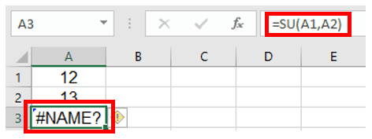

In the example shown above, I was trying to sum the values in cells A1 and A2 and show the result in cell A3 using the SUM expression.

I made a mistake in writing ‘SU’ instead of ‘SUM’ and so Excel is showing the #NAME? error.

* **#VALUE!**This error indicates that the argument or operator in a function is invalid. This happens if you are trying to use a cell containing text in your formula.

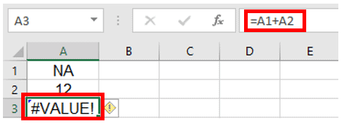

In the example above, I am trying to sum up cell A1 and cell A3 and display it in cell A3.

However, Excel shows a #VALUE! error since cell A1 contains ‘NA’ which is not a number.

* **#NULL!** This error is quite rare in Excel and is the result of a typo where a space character is used instead of a comma (, ) or colon ( : ) between two cell references. For example, typing A2 A5 instead of A2:A5.

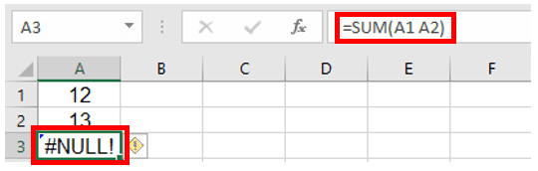

You can see in the above picture that I missed typing the colon ( : ) between A1 and A2 in the SUM formula above.

So Excel shows the #NULL! error.

* **#REF!**– The reference error occurs if you delete a cell or a range of cells that were being used in a formula.

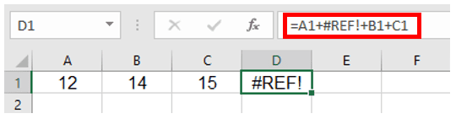

In this picture, I was adding values from cells A1 to D1 and displayed the result in cell E1.

However, I deleted the entire B column, and now Excel shows a missing reference error.

* **#N/A**– This error occurs when a formula or function cannot find the value it is looking for. For example, if you’re using a VLOOKUP function and it can not find the lookup value, it would return the #N/A error
* **#DIV/0!**This error code indicates that you are trying to divide a number by zero. Mathematically, the result can not be calculated and is undefined, so Excel shows this error.

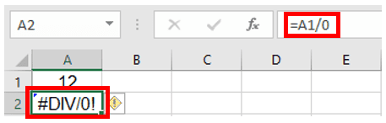

In the example above, I am trying to divide the value in cell A1 by 0, and so Excel is showing the #DIV/0! error.

* **#NUM!:** Num error occurs when a formula contains an invalid numeric value or an operation that produces a result that is too large or too small to be represented in Excel.

In this article, we have seen the different data types that are used by Excel for storing values.

The values can either be Numbers, Date and Time, Text, Logical Values, or Error Values.